**Appendix**

## A1 Python code

The main program reads the test data and calls for:

* An estimation of the Interest rate and Implied volatility;
* Simulation of the Greeks with Monte Carlo;
* A plot of the results.

The main code starts with:

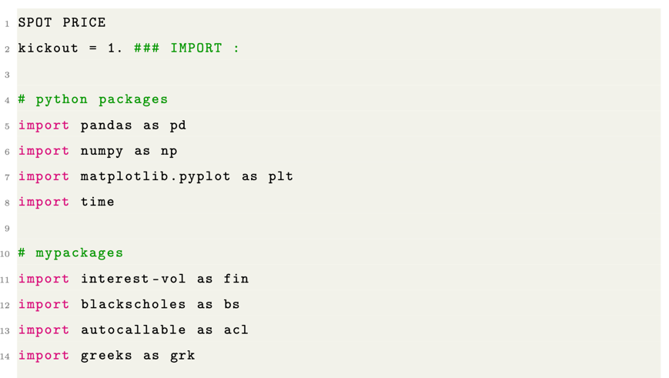

We estimate the volatility and interest rate with the following code

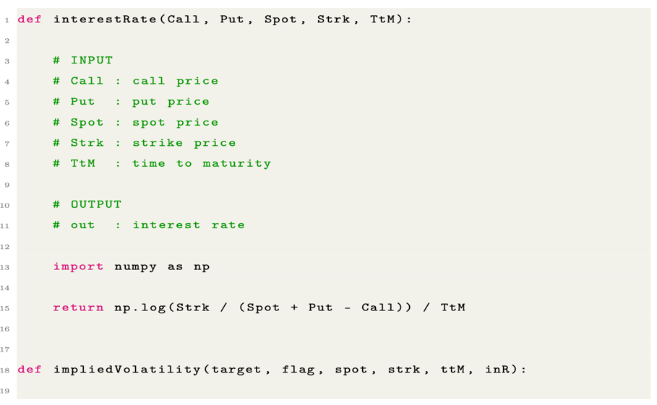

Pricing Call and Put option with the Black-Scholes formula

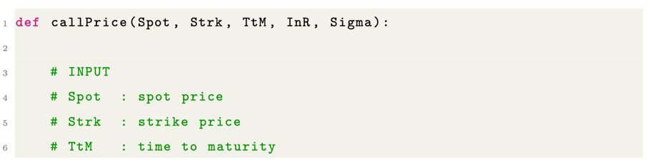

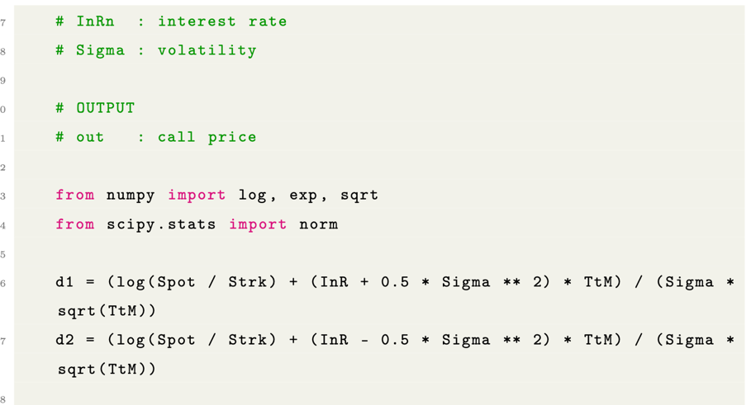

Simulating the discounted payoff and Pricing the Autocallable with Monte Carlo:

